This system predicts the CO2 emission of different segments of the roads during different time periods. The dataset I have used is this :   
<https://github.com/Chameleon-company/MOP-Code/blob/master/artificial-intelligence/Traffic%20Analysis/CO2%20emission%20prediction/Dataset/merged_traffic_datav1.csv>

I have plotted the actual data. The output is given below:

Here we can see that during 2015-2017 we have the highest amount of co2 emission in different areas of Melbourne.

Next step was to split the data into train and test.

In the above graph, the blue part represents the training data and the orange part represent the testing data.

In the dataset the date was and object type. As I am using time series , I converted the date into pandas date time type. Then I successfully plotted the data by year and month.

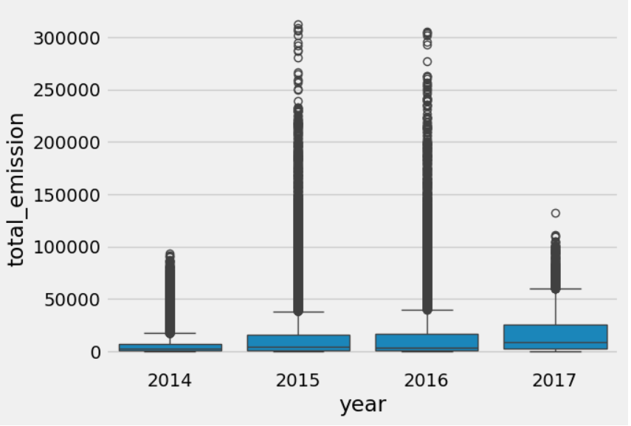

Above graph shows that 2015 and 2016 had most amount of carbon emission.

And this graph show that the highest number of emission was during October to December.

After prediction. I checked what part of the date time the model has used most. The result was that it used the year most to predict.

After predicting, I have plotted both the raw data and predicted data.

The result is not satisfactory as we can see from the graph that blue is the raw data and orange is the predicted. It happened because the dataset wasn’t curved properly . So the task is incomplete and needs more attention.